**Sweet dealmaking**

**称心的买卖**

(英文部分选自经济学人20220702期财经版块)

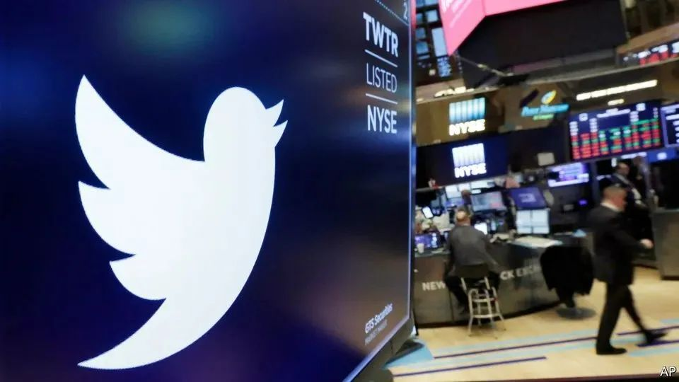

Corporate takeovers

公司收购

Sweet dealmaking

称心的买卖

The allure of betting on mergers

投机并购的诱惑

Big deals rarely happen without big personalities. If Elon Musk were an uninteresting tycoon with a low public profile and a puritanical approach to promises, then shares in Twitter, a social-media platform, would be trading within a whisker of his $54.20 per share offer. The difference, or “spread”, between this offer and Twitter’s current trading price, of below $40, is a reminder that he is not.

世纪交易的背后往往藏着充满个性的灵魂。如果埃隆·马斯克（ElonMusk ）只是一个无趣、低调且信守承诺的富商，那么社交媒体平台推特（Twitter）的股价应该与马斯克的收购报价（每股54.20美元）相差无几。而当前推特股票的交易价格还不到40美元。这之间的价差（或者说利差）提醒着我们，马斯克可不是“善茬”。

The wider the spread, the lower the chance investors assign to a deal completing. To Mr Musk and Twitter’s management, the spread is a live opinion poll in a fractious situation. But to a group of specialised hedge-fund managers, it is their bread and butter.

高价差意味着投资者认为这桩收购难以完成。对于僵持不下的马斯克和推特管理层而言，价差反映着市场对这桩并购的态度。但对那些专精于此的对冲基金公司来说，价差是他们的主要收入来源。

Merger arbitrage, also known as risk arbitrage, involves purchasing the shares of a target firm during the risky interval between a deal’s announcement and its completion. The arbitrager first identifies a merger that the market is relatively gloomy about—ie, a spread that they believe overestimates the chance of a deal’s failure. Then they buy shares in the company, and wait until the deal closes and the acquirer pays the offered price per share. The amount of capital dedicated to this strategy has quadrupled during the past decade to more than $100bn, despite some patchy returns. For several reasons, its star will continue to rise.

合并套利，又称风险套利，指通过在并购宣布和并购完成之间的高风险时间区间购买目标企业的股份来谋利。首先，套利者将目光锁定市场不看好的兼并案（在他们看来，这些交易的价差夸大了收购失败的几率）。然后，套利者购入该企业的股票份额，耐心等待，直到交易完成，买方按收购报价购入股票。过去十年间，尽管有时收益不尽如人意，运用这一投资策略投资的资金总额已翻了两番，超过了1000亿美元。而出于以下几个原因，风险套利的前景还将继续向好。

For a start, big deals are in plentiful supply. It is no coincidence that this strategy came of age during America’s buyout boom of the 1980s. After a **white-hot** 2021, more than 50 deals with a value exceeding $5bn have been announced so far this year. Companies’ balance-sheets are stocked with cash and **tumbling** valuations have created bargains. The arbitragers are not yet seeing any signs of recession.

首先，大宗并购交易层出不穷。这一投资策略在上世纪80年代美国公司收购潮时期成熟绝非偶然。在经历了2021年“白热化”的收购潮后，截至目前，今年宣布的价值逾50亿美元的并购又已超50起。很多企业资产负债表中现金充裕，而其他公司估值则大幅跳水，这让收购者心痒难耐。套利者们仍未看到任何收购潮退去的迹象。

The deals themselves also need to have some controversy associated with them. Ideally, someone should be trying, and failing, to kill them. Here lies another tailwind: that regulators are in an interventionist mood. Corporate synergies are coming up against national-security and antitrust concerns. Shares in Avast, a Czech cyber-security firm, **were edging towards** the price offered by NortonLifeLock, its bigger American competitor, before Britain’s Competition and Markets Authority said it was taking a closer look at the deal in March. More than $1bn **was wiped off** the market value of a firm that was being bought for around $8bn. Arbitragers were not far behind: around a quarter of Avast’s stock is currently in the hands of hedge funds that bought only after the deal was announced.

同时，只有“是非”多，交易才能“红”。理想情况下，应该有人试图扼杀这些交易，但以失败告终。好巧不巧，监管机构热衷于出手干预。国家安全和反垄断方面的考虑阻碍着企业间的并购。捷克网络安全公司Avast的股价曾经一度向美国NortonLifeLock公司提出的收购报价慢慢靠拢，后者是Avast的竞争者，且规模更大。但三月，英国竞争和市场管理局表示其正在仔细审查这项并购。这家原先收购价高达约80亿美元的公司市值应声蒸发了10多亿美元。套利者也紧随其后：对冲基金持有大约四分之一的Avast股票，均为交易宣布后才买入。

注释：1.synergy：If there issynergy between two or more organizations or groups, they are more successful when they work together than when they work separately. 协同作用2.Avast：Avast Software s.r.o.是一家总部位于捷克布拉格的电脑安全公司，主要研发电脑保安软件、机器学习和人工智能。该公司在全球25个办事处拥有约1700名员工。截至2020年4月，Avast的月活跃用户超过4.35亿，在全球防毒软件厂商中市场份额排名第二。3. NortonLifeLock：是一家总部设于美国亚利桑那州坦佩的互联网安全技术厂商，创立于1982年3月1日，并在全球有40个国家设有分公司，在《财富》 500强企业名单中名列第391位，全球拥有20，500多名员工。NortonLifeLock是赛门铁克（Symantec）品牌及企业安全产品被博通收购后留下的消费者防毒及身份安全公司。2021年7月，NortonLifeLock宣布收购Avast。今年3月，收购交易遇到阻碍。英国反垄断监管机构表示，出于对市场竞争的担忧，将对此网络安全收购案进行更深入的调查。NortonLifeLoc表示，调查将推迟交易的完成，目前预计交易将在2022年中后期完成。

Warren Buffett, a celebrated investor who became an active and successful arbitrager early in his career, is returning to the action. In January Microsoft announced a blockbuster takeover of Activision Blizzard, a video-game developer. A gaping spread cause by internal strife and competition worries was enough to tempt Berkshire Hathaway, the conglomerate run by Mr Buffett, to increase its stake in the game-maker, to nearly 10%. Mr Buffett was already a shareholder. But some arbitragers have been known to screen investments by hiring translators, lawyers and even courtroom spies.

在职业生涯早期，著名投资者沃伦·巴菲特（Warren Buffett）曾是一名活跃且成功的套利者，如今他正在重返赛场。今年1月，微软抛出重磅炸弹，宣布将收购电子游戏开发商动视暴雪公司。内部矛盾和反垄断担忧引起的价差足以吸引巴菲特名下的企业集团伯克希尔-哈撒韦公司（Berkshire Hathaway）增持暴雪的股份至近10%。巴菲特先生本身就是股东，但据信某些套利者会通过雇佣翻译、律师甚至法庭间谍来筛选投资项目。

注释：1. Activision Blizzard：动视暴雪是一家位于美国加利福尼亚州圣塔莫尼卡市的电子游戏控股公司。此公司于2008年7月经由动视（动视发行的上市母公司）与威望迪游戏两间公司合并所创立。动视暴雪在纳斯达克交易所底下以ATVI的代号交易，且从2005年起为标准普尔500指数的组成股票之一。动视暴雪目前由五个单位组成：动视发行、暴雪娱乐、King、MLG（大联盟游戏）以及动视暴雪影业。旗下拥有众多游戏版权，包括魔兽世界、炉石战记等等。2022年1月18日，微软宣布将以687亿美元收购动视暴雪。收购后，动视暴雪将成为Xbox游戏工作室的一员，同时让微软成为继腾讯游戏和索尼互动娱乐之后的第三大游戏公司。2.Strife：Strifeis strong disagreement or fighting. 冲突

The final bump comes from rising interest rates. Spreads are widened by an increase in the risk-free rate, since investors demand a higher rate of return for holding shares; those piling their capital into merger-arbitrage funds salivate at the thought of inflation-proof returns largely uncorrelated with the wider stockmarket.

最后一个原因和加息有关。无风险利率的上升会拉大价差，因为投资者希望自己持有的股票能带来更高的回报率；一想到有一项投资能对抗通胀，且收益基本不受股市大环境影响，把资金投入合并套利基金的投资者就会不由地垂涎三尺。

注释：1.risk-free rate: 无风险利率,或称或称零风险利率，是指一项没有风险的投资可得到的理论投资报酬率。正因为其没有风险，也就表示投资者冒风险进行投资而要求的利率要高于无风险利率。Source:https://zh.m.wikipedia.org/zh-hans2.salivate:to show great desire or anticipation : DROOL v.使流涎Source: https://www.merriam-webster.com/dictionary/salivate3.uncorrelated:having no mutual relationship; not affecting one through changes in the other;not correlated adj.非束缚的；无关联的4.在1980年代的收购热潮中，合并套利成为对冲基金投资策略的最前沿。在这个策略还很新而且缺乏实质性竞争的时候，回报非常高，一些套利公司的年均回报率超过20％。值得注意的是，沃伦·巴菲特（Warren Buffett）于1988年通过并购套利投资获得了53％的回报率。这些高回报率尤其值得注意，因为它们通常不依赖于股市指数的方向。并购套利通常会产生绝对回报，即与股票市场的总体方向无关的正投资回报。

The catch is that not every merger is completed. “If the deal goes through, we make some money. And if the deal doesn’t go through, who knows what happens,” ruminated Mr Buffett recently. The “who knows” part is also now more complicated. The price shares would **trade at** following a deal’s collapse, a crucial determinant of the risk-reward calculation for an arbitrage strategy, becomes harder to assess when markets are volatile and valuations uncertain. But arbitragers have, at least, been given a heady cocktail of dealmaking, corporate complexity and rising rates.

合并套利也有隐患，因为并非每桩并购交易都能完成。巴菲特最近就感慨道：“如果交易达成，我们就能赚到钱。如果交易失败，天知道会发生什么。”现在，“天”也不知道会发生什么了。在合并套利策略中，交易失败后的股价是计算风险回报的关键决定因素，但在市场波动、估值不定的背景下，对其进行评估变得愈发困难。但现在，层出不穷的并购交易、复杂的企业运作和高企的利率酿成的美酒已经让套利者们上头了。

注释：1.catch: a concealed difficulty or complication n. 潜在的困难、难题或是并发症<医>Source: https://www.merriam-webster.com/‍dictionary/catch2.ruminate：to go over in the mind repeatedly and often casually or slowly  v.反复考虑；沉思